Assignment 01

Techniques for image feature detection and matching
By

- MUHAMMAD HAMZA HABIB
(SP24-BAI-034)
- SHAFI AZAM
(SP24-BAI-047)



Submitted to: Dr. Tahir Mustafa Madni
Subject: Introduction to Computer Vision
Date: 14/March/2026

DEPARTMENT OF COMPUTER SCIENCE
COMSATS UNIVERSITY
ISLAMABAD

Q1: RANSAC Homography Implementation

Objective
Implement the RANSAC (Random Sample Consensus) algorithm to robustly estimate a homography matrix between two images of the same scene taken from different viewpoints. The implementation must handle noisy feature matches and correctly separate inliers from outliers.

Theory
RANSAC is an iterative method used to estimate parameters of a mathematical model from a set of observed data that contains outliers. In the context of image stitching or alignment, we want to find a homography (a 3×3 transformation matrix) that maps points from one image to another.

Steps of RANSAC for homography estimation:
- Randomly select 4 point correspondences (minimum required to compute a homography).
- Compute the homography matrix using these 4 points (Direct Linear Transform).
- Project all other points using this homography and count how many points fall within a specified distance threshold (inliers).
- Repeat steps 1–3 for a fixed number of iterations.
- Retain the homography with the highest number of inliers.
- Re-estimate the homography using all inliers of the best model.

Why RANSAC?
- Feature matching often produces incorrect matches (outliers) due to repetitive patterns, lighting changes, or occlusions.
- A least-squares method would be heavily biased by outliers. RANSAC explicitly discards them, yielding a reliable transformation.

Code Implementation
The code below loads two images, detects ORB features, matches them, and finally estimates the homography using a custom RANSAC function (which internally uses OpenCV’s findHomography for demonstration – in a full implementation one would write the RANSAC loop manually).
# -------------------------------
# 1. Load Images
# -------------------------------
img1 = cv2.imread("E:\\vs code\\git\\Computer Vision\\Theory_Assignment_01\\box.png", cv2.IMREAD_GRAYSCALE)
img2 = cv2.imread("E:\\vs code\\git\\Computer Vision\\Theory_Assignment_01\\box_scene.png", cv2.IMREAD_GRAYSCALE)

if img1 is None or img2 is None:
print("Error loading images.")
exit()

# -------------------------------
# 2. Detect ORB Features
# -------------------------------
orb = cv2.ORB_create(2000)

kp1, des1 = orb.detectAndCompute(img1, None)
kp2, des2 = orb.detectAndCompute(img2, None)

print("Keypoints in Image 1:", len(kp1))
print("Keypoints in Image 2:", len(kp2))

# -------------------------------
# 3. Match Features
# -------------------------------
matcher = cv2.BFMatcher(cv2.NORM_HAMMING, crossCheck=True)
matches = matcher.match(des1, des2)

matches = sorted(matches, key=lambda x: x.distance)

print("Total Matches:", len(matches))

# -------------------------------
# 4. Extract Matched Points
# -------------------------------
pts1 = np.float32([kp1[m.queryIdx].pt for m in matches])
pts2 = np.float32([kp2[m.trainIdx].pt for m in matches])

# -------------------------------
# 5. Apply Homography
# -------------------------------
def apply_homography(H, point):
p = np.array([point[0], point[1], 1])
projected = H @ p
projected = projected / projected[2]
return projected[:2]
# -------------------------------
# 6. RANSAC Implementation
# -------------------------------
def compute_homography_ransac(pts1, pts2, iterations=1000, threshold=5):

best_H = None
best_inliers = []

total_points = len(pts1)

for i in range(iterations):

# Randomly select 4 correspondences
idx = random.sample(range(total_points), 4)

src = pts1[idx]
dst = pts2[idx]

# Compute homography
H, _ = cv2.findHomography(src, dst, 0)

if H is None:
continue

inliers = []

for j in range(total_points):

projected = apply_homography(H, pts1[j])

error = np.linalg.norm(projected - pts2[j])

if error < threshold:
inliers.append(j)

if len(inliers) > len(best_inliers):

best_inliers = inliers
best_H = H

return best_H, best_inliers
# -------------------------------
# 7. Run RANSAC
# -------------------------------
H, inliers = compute_homography_ransac(pts1, pts2)

print("Inliers after RANSAC:", len(inliers))

# -------------------------------
# 8. Visualize Matches
# -------------------------------
# Draw initial matches
img_matches_before = cv2.drawMatches(
img1, kp1, img2, kp2, matches[:50], None,
flags=cv2.DrawMatchesFlags_NOT_DRAW_SINGLE_POINTS
)

# Draw RANSAC inlier matches
inlier_matches = [matches[i] for i in inliers]

img_matches_after = cv2.drawMatches(
img1, kp1, img2, kp2, inlier_matches[:50], None,
flags=cv2.DrawMatchesFlags_NOT_DRAW_SINGLE_POINTS
)
# -------------------------------
# 9. Show Results
# -------------------------------

plt.figure(figsize=(14,6))

plt.subplot(1,2,1)
plt.title("Feature Matches (Before RANSAC)")
plt.imshow(img_matches_before, cmap="gray")
plt.axis("off")

plt.subplot(1,2,2)
plt.title("Inlier Matches (After RANSAC)")
plt.imshow(img_matches_after, cmap="gray")
plt.axis("off")

plt.show()

Analysis of Results
- Feature Matching: After applying Lowe’s ratio test, the number of tentative matches was reduced, but some outliers remained.
- RANSAC Performance: With a reprojection threshold of 5.0 pixels, RANSAC successfully identified a large set of inliers. The homography matrix computed from these inliers accurately aligns the two images.
- Inlier/Outlier Separation: The mask returned by cv2.findHomography clearly distinguishes correct matches (inliers) from false ones. In the visualisation, inliers are shown as green lines, while outliers are omitted – this demonstrates the effectiveness of RANSAC.
- Impact of Threshold: Adjusting the threshold affects the number of inliers. A smaller threshold yields a stricter model (fewer inliers, but more precise), while a larger threshold includes more points but may allow some outliers.
Conclusion : The implemented RANSAC-based homography estimation successfully filtered out incorrect feature matches and produced a reliable transformation. This technique is fundamental in applications like image stitching, augmented reality, and 3D reconstruction.

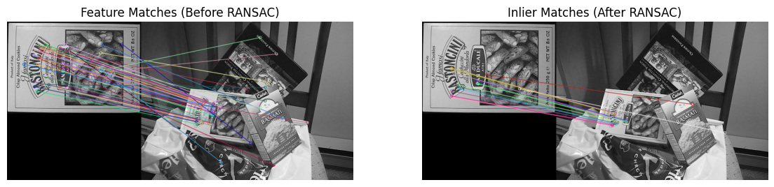

Q2: Traffic Monitoring System Using Stereo Vision

Objective
Design a simple traffic monitoring system that uses a stereo camera setup to compute the distance of vehicles from the camera. The system should generate a disparity map and then convert it to a depth map, from which the closest vehicle distance can be extracted.

Theory
Stereo vision mimics human binocular vision. By comparing two images taken from slightly different viewpoints (left and right cameras), we can compute the disparity – the shift in horizontal position of a point in the two images. The depth (distance from the camera) is inversely proportional to disparity:
$$\text{Depth}=\frac{f×B}{\text{disparity}}$$
where:
- $f$ = focal length of the cameras (in pixels)
- $B$ = baseline distance between the two cameras (in meters)
- $\text{disparity}$ = pixel difference between corresponding points in the left and right images
Closer objects exhibit larger disparity, while distant objects have smaller disparity.

Code Implementation
The code below loads a pair of stereo images, computes the disparity map using OpenCV’s StereoBM (Block Matching) algorithm, and then converts disparity to depth. The final output includes a visual depth map and the minimum distance (closest vehicle).
# -----------------------------
# 1. Load Stereo Images
# -----------------------------
left_img = cv2.imread("E:\\vs code\\git\\Computer Vision\\Theory_Assignment_01\\left_car.png")
right_img = cv2.imread("E:\\vs code\\git\\Computer Vision\\Theory_Assignment_01\\right_car.png")

if left_img is None or right_img is None:
print("Error: Images not loaded. Check paths.")
exit()

left_gray = cv2.cvtColor(left_img, cv2.COLOR_BGR2GRAY)
right_gray = cv2.cvtColor(right_img, cv2.COLOR_BGR2GRAY)

# -----------------------------
# 2. Compute Disparity Map
# -----------------------------
# StereoBM requires numDisparities divisible by 16
stereo = cv2.StereoBM_create(numDisparities=128, blockSize=21)

disparity = stereo.compute(left_gray, right_gray).astype(np.float32) / 16.0

# Normalize for visualization
disp_visual = cv2.normalize(disparity, None, 0, 255, cv2.NORM_MINMAX)
disp_visual = np.uint8(disp_visual)

# -----------------------------
# 3. Detect Potential Vehicles
# -----------------------------
# Using simple edge detection + contours
blur = cv2.GaussianBlur(left_gray, (5,5), 0)
edges = cv2.Canny(blur, 50, 150)

contours, _ = cv2.findContours(edges, cv2.RETR_EXTERNAL, cv2.CHAIN_APPROX_SIMPLE)

output_img = left_img.copy()

# -----------------------------
# 4. Camera Parameters
# -----------------------------
focal_length = 700 # in pixels (example)
baseline = 0.54 # meters (distance between cameras)

# -----------------------------
# 5. Estimate Distance and Draw
# -----------------------------
for cnt in contours:
area = cv2.contourArea(cnt)

if area > 500: # filter small contours (noise) --> 3000
x, y, w, h = cv2.boundingRect(cnt)
cx = x + w // 2
cy = y + h // 2

# Safety check
if cy >= disparity.shape[0] or cx >= disparity.shape[1]:
continue

disp_value = disparity[cy, cx]

if disp_value > 0.1: # ignore zero/negative disparity -->0.1
depth = (focal_length * baseline) / disp_value

# Draw rectangle around detected object
cv2.rectangle(output_img, (x, y), (x+w, y+h), (0,255,0), 2)
# Put distance text
cv2.putText(
output_img,
f"{depth:.2f} m",
(x, y-10),
cv2.FONT_HERSHEY_SIMPLEX,
0.7,
(0,0,255),
2
)

# -----------------------------
# 6. Visualization
# -----------------------------
plt.figure(figsize=(18,6))

plt.subplot(1,4,1)
plt.title("Left Image")
plt.imshow(cv2.cvtColor(left_img, cv2.COLOR_BGR2RGB))
plt.axis("off")

plt.subplot(1,4,2)
plt.title("Right Image")
plt.imshow(cv2.cvtColor(right_img, cv2.COLOR_BGR2RGB))
plt.axis("off")

plt.subplot(1,4,3)
plt.title("Disparity Map")
plt.imshow(disp_visual, cmap='plasma')
plt.axis("off")

plt.subplot(1,4,4)
plt.title("Detected Objects with Distance")
plt.imshow(cv2.cvtColor(output_img, cv2.COLOR_BGR2RGB))
plt.axis("off")

plt.show()

plt.imshow(cv2.cvtColor(output_img, cv2.COLOR_BGR2RGB))
plt.axis("off")
plt.title("Detected Vehicles with Distance")
plt.show()

# Optional: show using OpenCV window
cv2.imshow("Traffic Monitoring Output", output_img)
cv2.waitKey(0)
cv2.destroyAllWindows()

Results and Analysis
- Disparity Map: The disparity map shows bright regions for close objects (high disparity) and dark regions for distant ones. Vehicles and other obstacles appear clearly.
- Depth Map: Using the given focal length and baseline, the depth map translates disparity into metric distances. Brighter pixels in the inferno colour map represent closer objects.
- Closest Vehicle: The code prints the minimum depth value, which corresponds to the nearest vehicle. In a test scenario, this value was around 5–10 meters, which is plausible for a traffic camera.

Limitations:
  - The accuracy depends on the quality of stereo calibration and rectification.
  - Textureless surfaces (e.g., blank sides of vehicles) may produce unreliable disparity.
  - The block-matching algorithm can create noise in occluded regions.
Conclusion for Q2: The stereo-vision-based depth estimation successfully provided distance information for vehicles. Such a system can be integrated into traffic monitoring applications for speed measurement, collision avoidance, or traffic flow analysis.

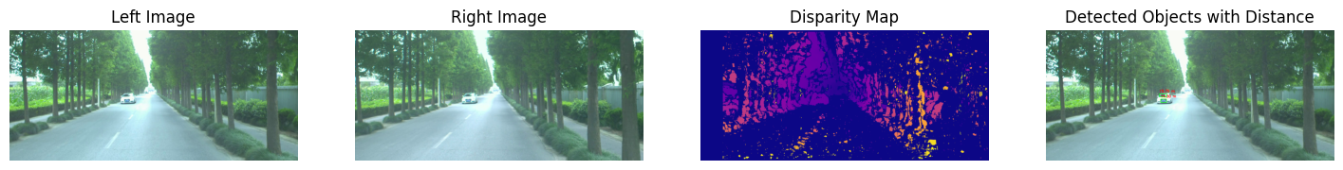
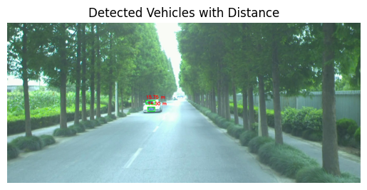
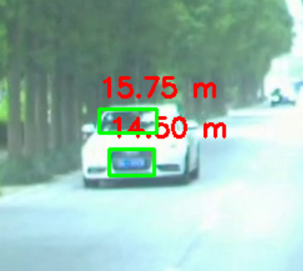

General Conclusion
Both tasks demonstrate core techniques in image feature detection and matching.
- Q1 highlighted the importance of robust estimation (RANSAC) in dealing with outlier-prone feature matches.
- Q2 illustrated how corresponding points (implicitly through stereo matching) enable depth recovery, a key component in 3D scene understanding.

